Code Challenge : 7

Time : 90 mts

1. Write a JavaScript program to calculate multiplication and division of two numbers (input from user).

Sample Form:

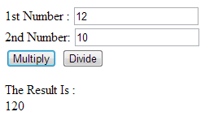

1. Write a JavaScript for loop that will iterate from 0 to 15. For each iteration, it will check if the current number is odd or even, and display a message to the screen.

Sample Output :

"0 is even"  
"1 is odd"  
"2 is even"

1. Write a JavaScript program that creates a button and add a click event listener to log a message when it's clicked.
2. Use and write the correct selector to hide all odd table rows in a table.
3. Find all h1 elements that are children of a div element and apply a background to them.
4. Write a jQuery Code to get a single element from a selection.

Sample:

<body>

<ui>

<li>CSHARP</li>

<li>SQL</li>

<li>ADO</li>

</body>

1. Write a jQuery Code to add a tag at the beginning of the list item, containing the index of the list item Sample:

<body>

<ui>

<li>CSHARP</li>

<li>SQL</li>

<li>ADO</li>

</body>.

As

0 CSHARP

1 SQ: etc..

1. Append a <p> element with a text message when an <input> field is changed.